1. Calculating hash(type: MD5)

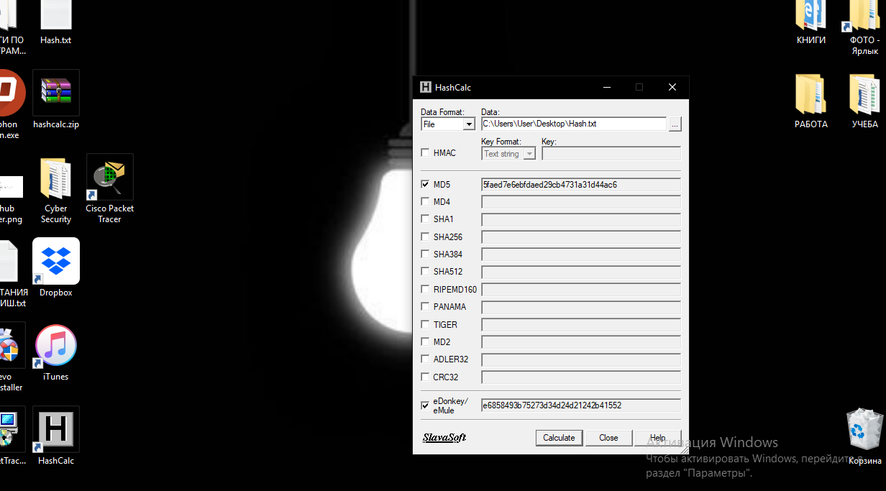

2. Hash after changing the text from file we have another hash

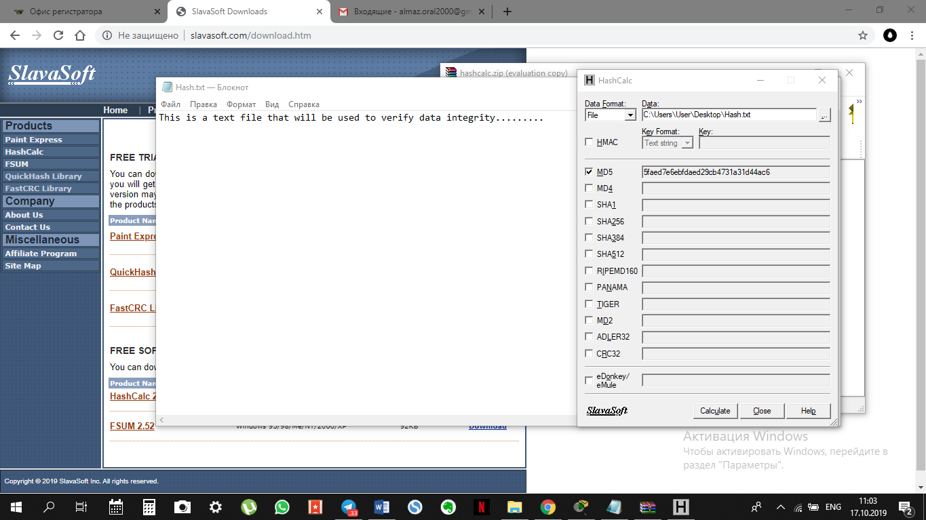

3. Calculating other type of hash

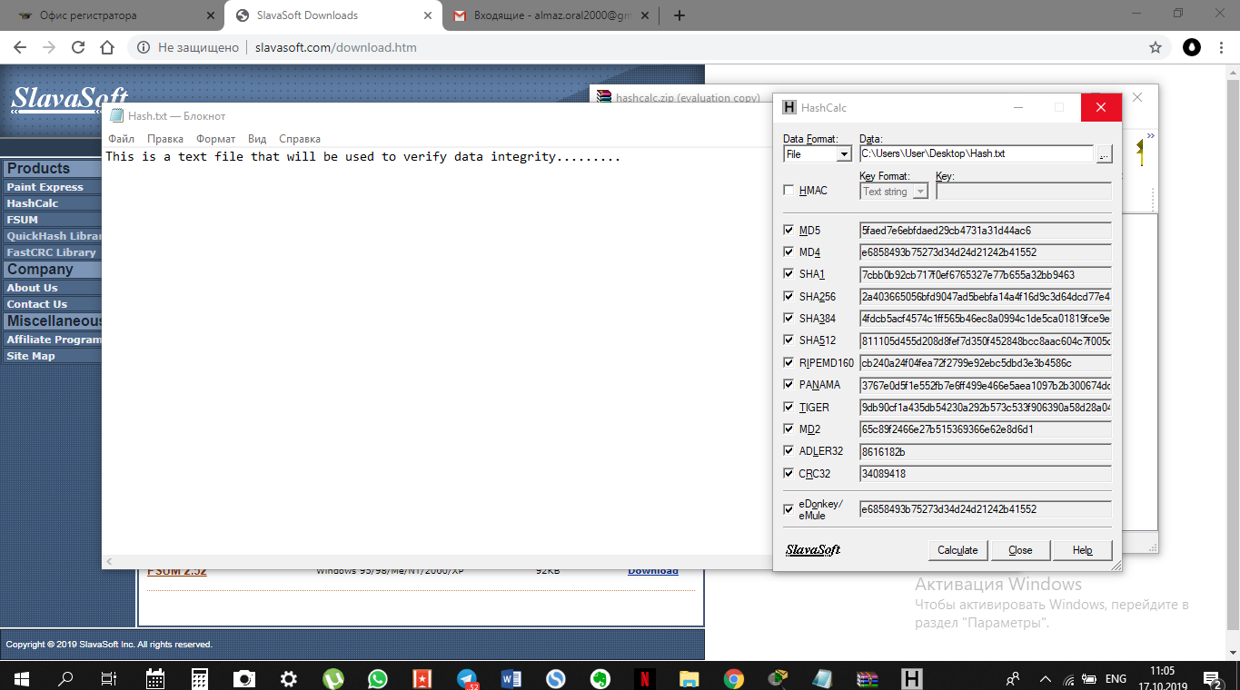

Answer: For each hash-function exist special method for calculating the hash.